**Day 28:**

**Micro Service:** Micro Service, means the service which serve for small or micro task.

While developing big or enterprise level application we need n number of modules.

Login Module, Customer module, Product module, Order Module, Payment module etc

Login Module

Team 1 or Dev1

Login Java bean or entity class login table.

LoginController

LoginService

LoginRepository or LoginDao

Team 2 or Dev3

Product module

Product Entity class

Product Controller

Product service

Product Repository etc

Team 3 or Dev3

Payment module

Payment entity class

Payment controller

Payment service

Payment dao or repository etc

After combine we need to build the project and deploy on server. Etc.

In this approach

Every team depends upon other team code or module.

If we want to do any changes on particular module. After done changes according to client requirement we need to merge once again all modules and re-deploy on actual server.

If any issue in any particular module it effect for whole project.

All modules must be develop using same language.

We need to use same database.

In micro service we can create more than one module using same language or different language. We can use same database or different database. Every tea m or developer once they finish their task they deploy jar or war file independently

In this approach each module running on different port number.

8181

8282

8383

8484

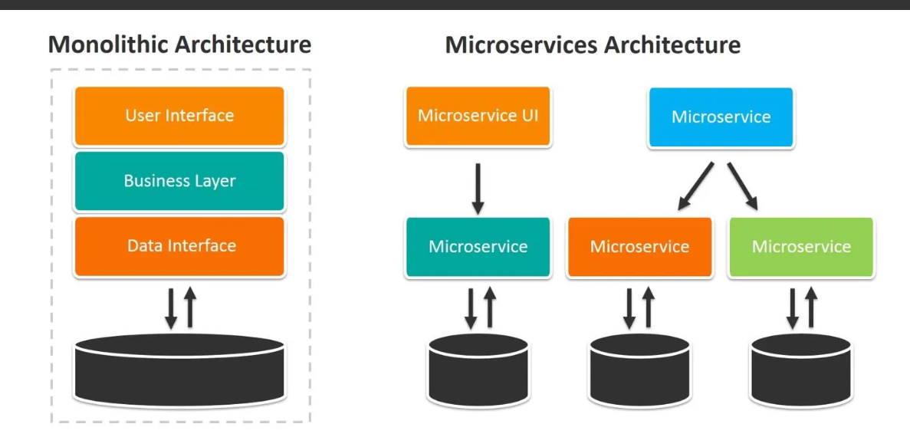

Spring boot provided

Spring cloud module which help to achieve micro service architecture.

Spring boot provided one source server ie Eureka Server. Eureka Server is a type of server which help to deploy more than one micro service creating using java or as well as other technologies. Eureka server is a part of Netflex.

Eureka server keep the track or health of all micro service deploy using same or different language.

1st Project: Eureka Server

Starter -🡪Eureka Starter

Starter 🡪 Web Starter

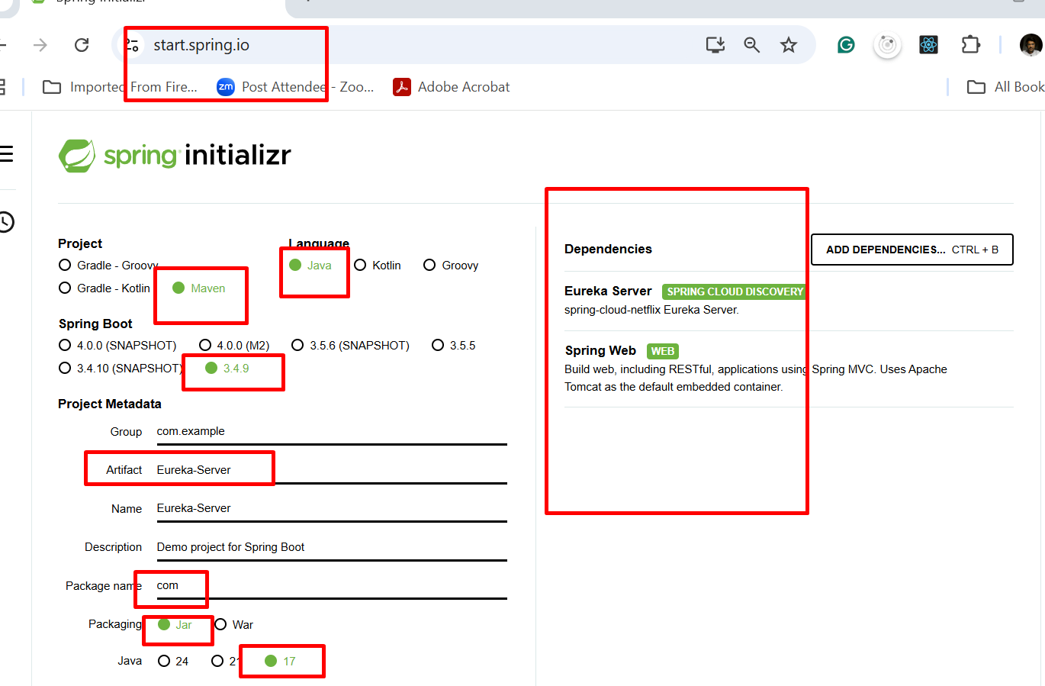

By default tomcat run on server 8080. This project contains eureka server so eureka server start on 8080.

But whenever we create one or more than one micro service by default each micro service project search eureka server on 8761 port number. 8761 is default port number for eureka server.

2nd Project: 1st Micro Service Project: Creating Simple Rest API

Starter 🡪 Web Starter

Starter 🡪Eureka discovery client

server.port = 8181

